Physics 30 1996 January

Use the following information to answer the next three questions.

When a motor vehicle slows down suddenly and the wheels are locked, the kinetic energy of the vehicle is transferred into heat energy. A skid mark is left on the road. Police can estimate the speed at which a vehicle was travelling before the brakes were applied b measuring the length of a skid mark d and applying the formula 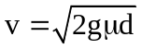, where μ = 0.750 for a dry road surface.

After the brakes are applied and the wheels are locked, a 1.00 x 10³ kg vehicle comes to a stop in 3.80 s. The vehicle leaves a 52.9 m skid mark.

Numerical Response

- The estimated speed of the vehicle is calculated to be __________ m/s.

(Record your three-digit answer in the numerical-response section on the answer sheet.)

Use your recorded answer from Numerical Response 1 to answer Numerical Response 2.

Numerical Response

- Assume a closed system between the vehicle and the road, such that the vehicle's kinetic energy is converted to heat. The amount of kinetic energy transformed into heat energy while the vehicle stops, expressed in scientific notation, is b x 10^{w} J. The value of b is __________.

(Record your three-digit answer in the numerical-response section on the answer sheet.)

Use your recorded answer from Numerical Response 1 to answer Numerical Response 3.

Numerical Response

- The magnitude of the impulse necessary to stop the vehicle, expressed in scientific notation, is b x 10^{w} kg·m/s. The value of b is _________.

(Record your three-digit answer in the numerical-response section on the answer sheet.)

Use the following information to answer the next three questions.

Five cars were used in a test designed to study how injuries to the occupants of a car could be reduced.
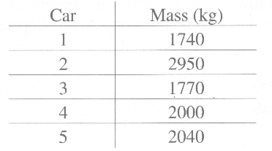

- Each car was designed with energy-absorbing crumple zones. Car 4, travelling at 100 km/h (27.8 m/s), was crashed into a wall and became 0.500 in shorter during impact. The average retarding force was
A. 1.36 x 10⁶ N
B. 1.54 x 10⁶ N
C. 1.57 x 10⁶ N
D. 2.36 x 10⁶ N

- The automatic braking system in each car was designed to activate if the car encountered a sudden head-on force equal to or greater than 1.25 x 10⁴ N. The activator uses an instrument that measures average force. In which cars would the braking system activate if each vehicle were forced to stop from 100 km/h in 4.0 s?
A. 1, 2, and 4
B. 1, 3, and 4
C. 2, 3, and 5
D. 2, 4, and 5

- The 1740 kg car travelling north on an icy test area was crashed into the 2000 kg car travelling west. The test designers found that the two vehicles locked together on impact and slid at 9.0 m/s at 35º west of north. What was the speed of the 1740 kg car just before impact?
A. 16 m/s
B. 11 m/s
C. 8.5 m/s
D. 5.9 m/s

Use the following information to answer the next two questions.

Thundercloud
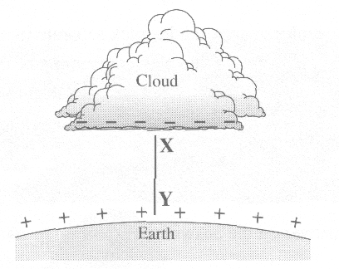

- If the bottom of a cloud is relatively negative and the surface of Earth is relatively positive, then the direction of the resulting electric field, along line XY, can best be pictured as
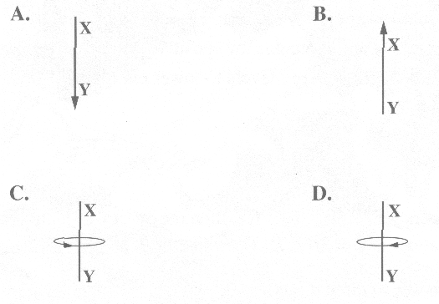

- Assume the bottom of the cloud and the surface of Earth are parallel and that they are separated by a distance of 2.00 km. If a potential difference of 5.00 x 10⁸ V is created between the bottom of the clouds and the surface of Earth, the magnitude of the electric field created is
A. 2.50 x 10⁵ V/m
B. 2.50 x 10⁸ V/m
C. 1.00 x 10⁹ V/m
D. 1.00 x 10¹² V/m

Use the following information to answer the next three questions.

There are two stable isotopes of oxygen,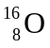 and 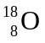. The ratio of to in the ice of ancient glaciers is an indication of past temperatures. A mass spectrometer is used to measure the numbers of and atoms in a sample of ice. It uses a potential difference to accelerate the oxygen ions (O²⁻) in a straight line. The path of the ions is then bent into circular motion by a magnetic field.
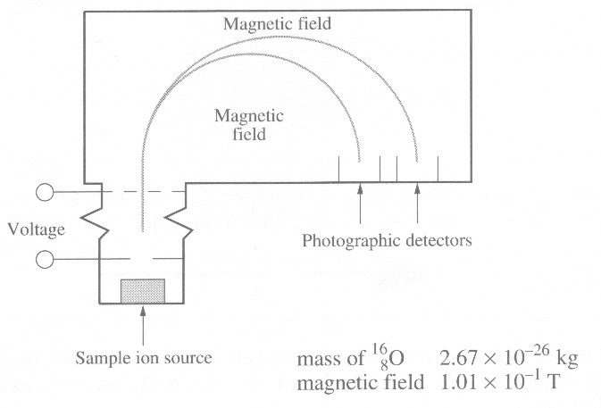

- The ions are negative. Therefore, to bend them into circular motion to the right, the direction of the magnetic field must be
A. into the page
B. out of the page
C. toward the top of the page
D. toward the bottom of the page

- Which statement correctly describes the difference between the two isotopes of oxygen?
A. has 2 more protons than
B. has 2 more neutrons than
C. has 2 more electrons than
D. has 2 fewer electrons than

Numerical Response

- The radius of the path for 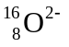 ions that are moving at a speed of 2.00 x 10⁵ m/s, expressed in scientific notation, is b x 10^{-w} m. The value of b is ___________.

(Record your three-digit answer in the numerical-response section on the answer sheet.)

- If a current-carrying wire runs directly over a magnetic compass, the needle of the compass will
A. point in a direction perpendicular to the wire
B. point in a direction parallel to the wire
C. tend to point directly to the wire
D. not be affected by the current

Use the following information to answer the next two questions.

The energy of ultraviolet radiation can be harmful to living organisms by breaking the chemical bonds of DNA. The ozone layer provides protection from the UV radiation of the Sun. Each ozone molecule can absorb UV radiation having wavelengths less than 295 nm.

Numerical Response

- Given the above data, the lowest frequency of ultraviolet light absorbed by an ozone molecule, expressed in scientific notation, is b x 10^{w} Hz. The value of b is _________.

(Record your three-digit answer in the numerical-response section on the answer sheet.)

Use your recorded answer from Numerical Response 5 to answer Numerical Response 6.

Numerical Response

- The minimum energy of UV radiation absorbed by an ozone molecule will be b x 10^{-w} J. The value of b is ___________.

(Record your three-digit answer in the numerical-response section on the answer sheet.)

Use the following information to answer the next question.

Scattering of Alpha Particles

Three alpha particles travelling at the same speed are deflected by the nucleus of a gold atom.
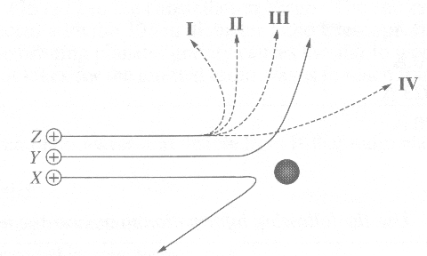

- If particles X and Y are deflected as shown, particle Z will take path
A. I
B. II
C. III
D. IV

Numerical Response

- Northern lights are often observed in Alberta skies. They occur as a result of a collision between electrons from the solar wind and oxygen atoms in the upper atmosphere. The oxygen atoms are excited after the collision. The most common colour, green, has a wavelength of 480 nm. To produce this colour, the electrons must be travelling with a minimum speed, expressed in scientific notation, of b x 10^{w} m/s. The value of b is __________.

(Record your three-digit answer in the numerical-response section on the answer sheet.)

- A transformer has 4000 turns on the primary coil and operates at 400 V AC with a current of 0.460 A. Assuming 100% efficiency, if the secondary coil of the transformer has 200 turns, then the current in the secondary coil is
A. 23.0 A
B. 92.0 A
C. 0.023 A
D. 9.20 A

Use the following information to answer the next two questions.

An electrician has to install a step-down transformer that will be used to run a doorbell. The household supply voltage is 110 V (AC) and the doorbell requires only 16 V (AC).

- If the doorbell draws 0.50 A of current, then the current drain from the household supply, assuming 100% efficiency, will be
A. 0.073 A
B. 0.29 A
C. 3.4 A
D. 14 A

- On another circuit in the house, the primary coil of a different transformer draws 1.0 x 10⁻² A. The transformer is only 95% efficient, losing energy to the environment due to heat and vibration. The total energy it will lose in 1.0 day is
A. 9.0 x 10⁴ J
B. 4.8 x 10³ J
C. 4.0 x 10³ J
D. 2.0 x 10² J
___________________________________

Use the following information to answer the next three questions.

There is strong evidence that at least two planets are orbiting the pulsar neutron star PSRB 1257+12 in the constellation Virgo. The star emits radio waves that are detected with the 305 m diameter radio telescope in Puerto Rico. However, the orbiting planets’ gravity causes the star to wobble in its rotation. The time it takes for the emitted radio waves to reach Earth varies.

- One difference between radio waves and visible light is that radio waves
A. cannot be reflected
B. cannot travel through a vacuum
C. travel at a lower speed in a vacuum
D. have a longer wavelength than visible light

- Radio waves from space longer than 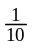 the diameter of the radio telescope are undetectable on Earth's surface because of atmospheric interference. What is the approximate lower limit of the frequency of detectable waves?
A. 1.0 x 10⁻⁷ Hz
B. 32 Hz
C. 9.8 x 10⁶ Hz
D. 9.2 x 10⁹ Hz

Numerical Response

- When the radio waves arrive 3.1 x 10⁻³ s sooner than predicted, the pulsar's orbiting planets have pulled the source of radiation closer to Earth. The change in distance, expressed in scientific notation, is a.b x 10^{cd} m.
The values of a, b, c, and d are _____, _____, _____, and _____ .

(Record all four digits in the numerical-response section on the answer sheet.)

- The energy that must be absorbed for an electron in a hydrogen atom to make the transition from the 5th level to the 6th level is
A. 0.17 eV
B. 0.38 eV
C. 0.54 eV
D. 0.92 eV

Use the following information to answer the next two questions.

This chart lists energy levels of the outer electron orbits in the sodium atom.
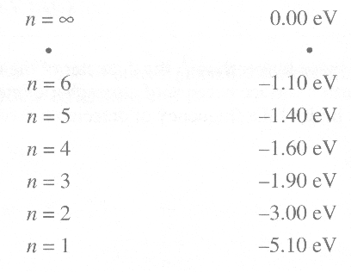

- The shortest wavelength of visible light emitted when an electron falls from the n = 6 level is
A. 2.40 x 10⁻⁷ m
B. 3.11 x 10⁻⁷ m
C. 1.10 x 10⁻⁶ m
D. 4.13 x 10⁻⁶ m

- When its electron is in the lowest energy level, the sodium atom is said to be in the
A. ionized state
B. excited state
C. ground state
D. unstable state

Use the following information to answer the next two questions.

Gamma rays in astronomy are associated with processes that involve tremendous amounts of energy other than radioactive decay. Because detector efficiency of gamma rays is very poor at ground level, detection is done by satellite.

- A gamma ray of frequency 1.75 x 10²⁰ Hz is produced by a solar flare. What is the period of the ray?
A. 1.71 x 10⁻²¹ s
B. 5.71 x 10⁻²¹ s
C. 1.75 x 10²⁰ s
D. 5.25 x 10²¹ s

- A strong or intense source of gamma rays would most likely indicate that
A. an explosion had occurred
B. a strong gravitational field is present
C. energy is being converted into matter
D. matter is being converted into energy
________________________________

- To what voltage would a cathode ray tube have to be adjusted to produce a photon that has a frequency of 3.00 x 10²⁴ Hz?
A. 1.99 x 10⁻⁹ V
B. 1.24 x 10¹⁰ V
C. 3.00 x 10²⁴ V
D. 1.88 x 10⁴³ V

Use the following information to answer the next question.

A Japanese car manufacturer is designing an automatic braking system that detects objects in a car's path. The system involves a detector that receives reflected laser signals.

- A signal sent by the laser is reflected and returned to the detector 0.15 μs after its transmission. The distance from the car to the detected object is
A. 15 m
B. 23 m
C. 42 m
D. 45 m

- When light of frequency 5.0 x 10¹⁴ Hz illuminates a metal surface, photoelectrons are emitted with a maximum kinetic energy of 1.8 x 10⁻¹⁹ J. The threshold frequency of the metal is
A. 4.5 x 10¹¹ Hz
B. 2.3 x 10¹⁴ Hz
C. 1.5 x 10¹⁹ Hz
D. 3.3 x 10¹⁹ Hz

Numerical Response

- A 0.050 MeV X-ray beam is used to take a child's chest X-ray. The child's chest is 9 cm thick and the half-distance for this radiation in body tissue is 3 cm. The ratio of the energy received by the chest surface to the energy received by the skin on the child's back is a to b.
The values of a and b are _____ and _____ .

(Record all two digits in the numerical-response section on the answer sheet.)

- Gamma radiation is chosen for food irradiation because it
A. is safe, low-energy radiation
B. is the easiest form of radiation to produce
C. penetrates into the food through its packaging
D. poses no danger to the technologists doing the irradiation

Use the following information to answer the next three questions.

In a number of nuclear power stations, the reaction material is Uranium 235. The 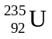 will spontaneously decay to produce Thorium 231 plus at least one other particle. The half-life of is 7.0 x 10⁸ years.

- One of the other particles that is produced during the decay process must be
A. an alpha particle
B. an electron
C. a neutron
D. a proton

- How long would it take 10.0 g of to decay to 1.25 g in a nuclear reactor?
A. 9.9 x 10⁻² y
B. 1.8 x 10⁸ y
C. 1.4 x 10⁹ y
D. 2.1 x 10⁹ y

- The fission ofwill release 200 MeV of energy per atom. This energy is related to the
A. initial kinetic energy of the initiating neutron
B. conversion of a nucleon to energy
C. formation of beta radiation
D. mass defect of the nucleus

